SPIRITWEAR SHIRTS
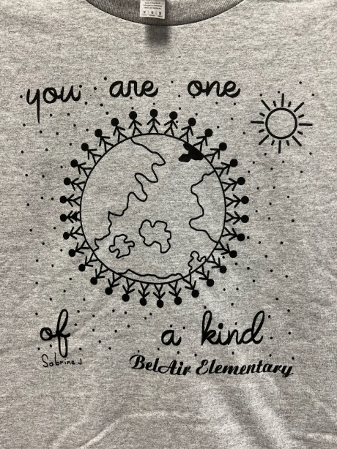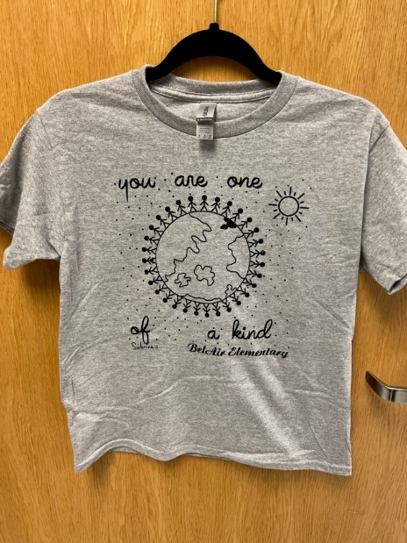

This year we had the students make a shirt design in Art class.
The students voted for the winning design for our Spiritwear shirt for FY 23
Congratulations Sabrina J!
Prices:
Youth Medium – Adult XL - $10.00
Adult XXL - $12.00
Adult XXXL - $14.00
You can also purchase on RYCOR in your child account and pay by debit or credit card.
CHILD NAME ___________________________________________________________
TEACHER ______________________________ GRADE _______________
ORDER: YM _______ YL _______
AS _______ AM _______ AL ________
AXL _______ AXXL _______ AXXXL _________

TOTAL COST: _____________
ALL ORDERS MUST BE PAID FOR AT TIME OF ORDER.

